Name: Mriganka Patra
Email: mriganka.patra@cognizant.com
Emp ID: 2415820

Day 18
Sprint 1 Submission

Objective: Implement the baes CRM logic with record types, automation, visibility settings, and uesr management

Task 1.4: As an admin I want to set visibility rules for data so that users only see records relevant to their role.

- Go to setup > home
- Search for sharing settings

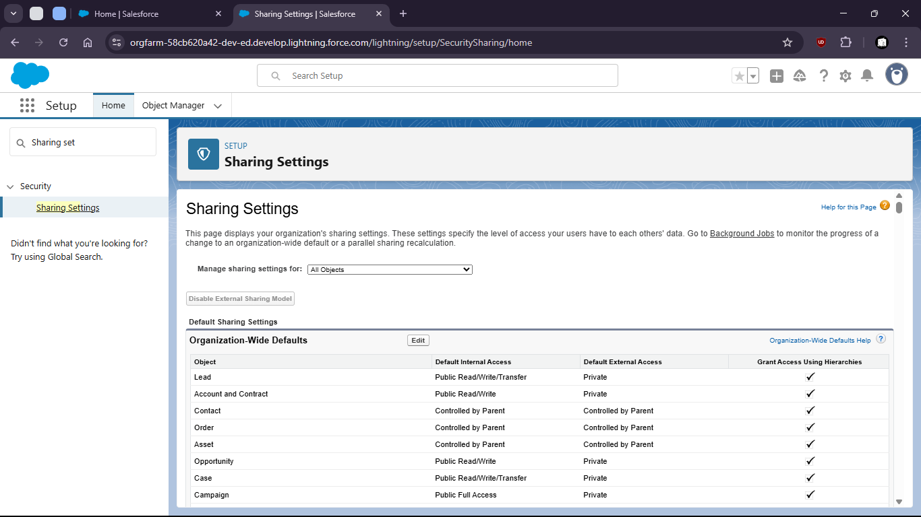

- Make changes to org wise defaults

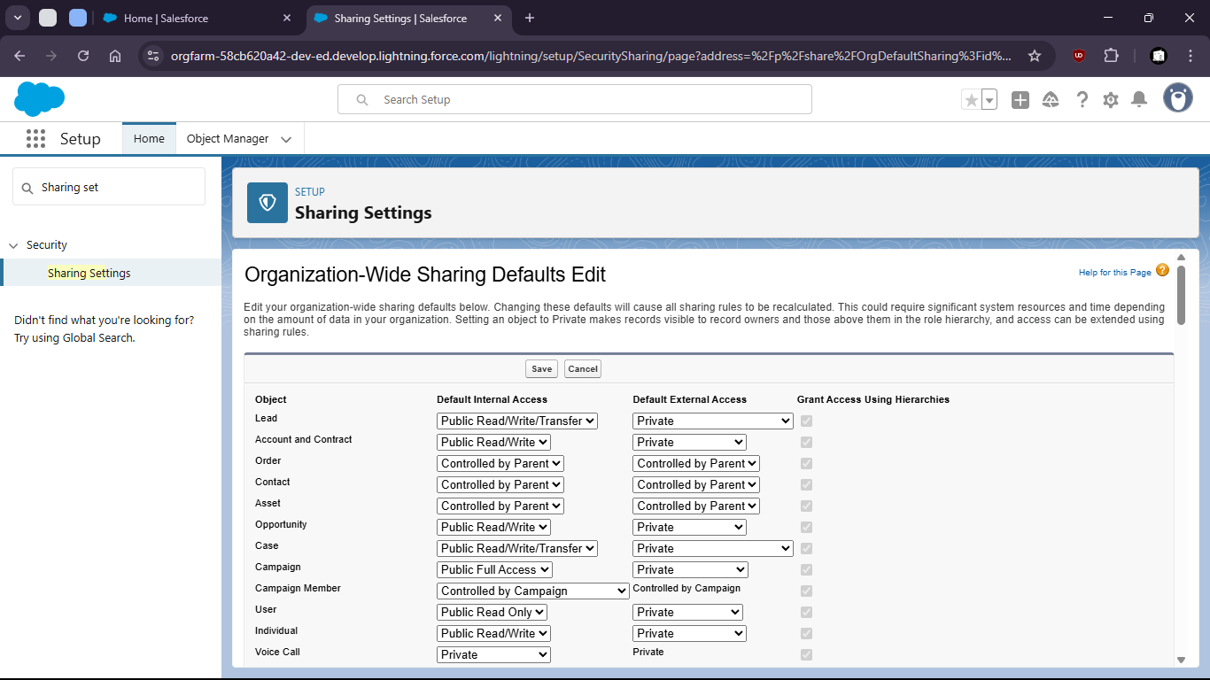

- Now goto home > Roles

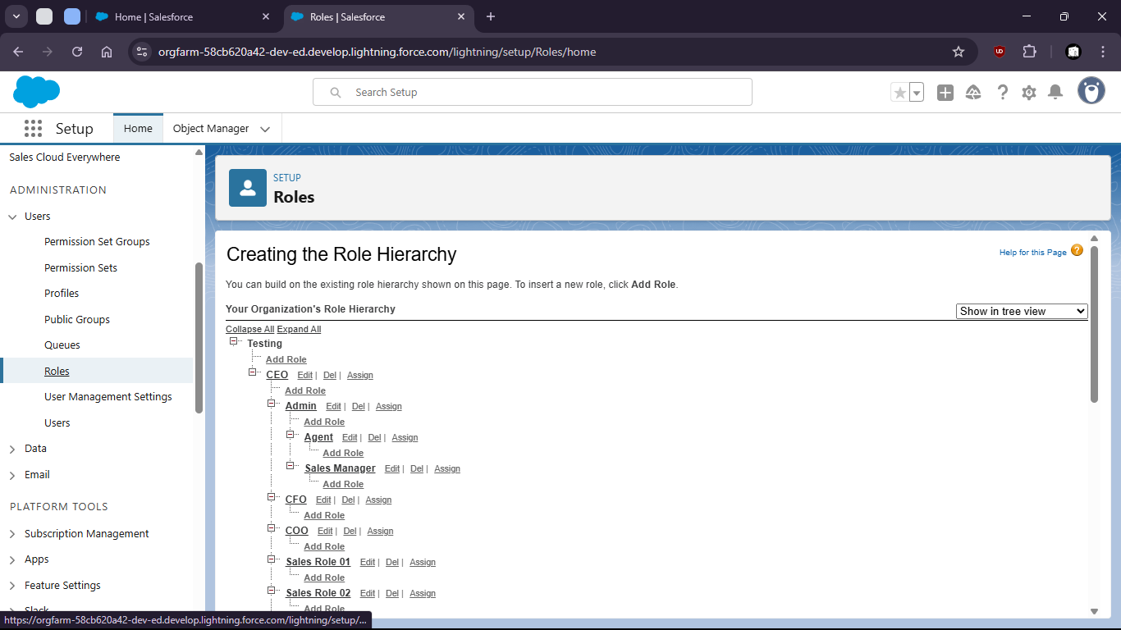

- Set up roles under CEO as Admin

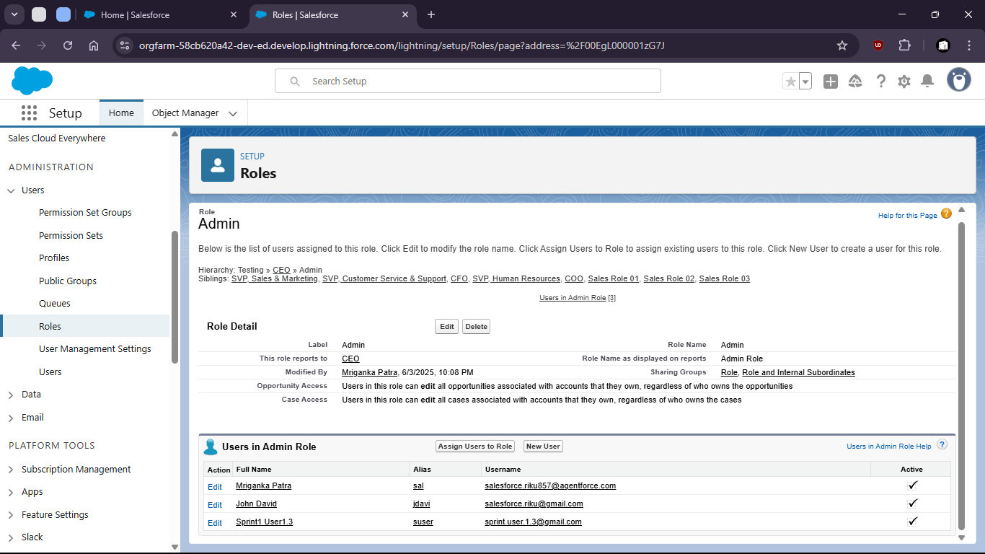

- Look for assigned users to this role

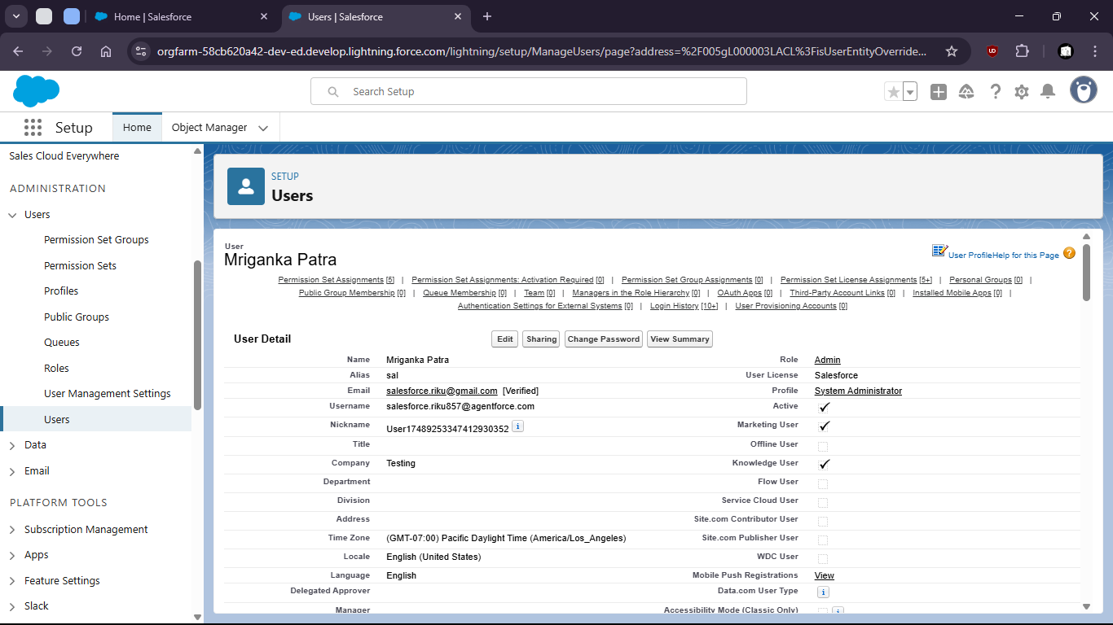

- For the assigned users in that Role create a sharing rule

